Dareck Giuliani

Fernbach

Customer Analytics

February 6, 2018

Maru Batting Center

**Part 1: Case Questions**

1. Calculating over an infinite time horizon changes CLV slightly; until survival rate reaches zero customers can contribute value.
2. I chose to use $CLV= \frac{M(1+d)}{1+d-r}-AC$ because MBC receives their payment at the end of the first session, meaning funds are not discounted until the next year.
3. Customer Acquisition Cost:
   1. Little Leaguer: ¥10,000
   2. Summer Slugger: ¥10,000
   3. Elite Ballplayer (print ad): ¥60,000
   4. Elite Ballplayer (party): ¥50,000
   5. Entertainment Seekers: ¥2,000
4. Without discounting cashflow how soon will MBC break even?
   1. Little Leaguer: Year 2
   2. Summer Sluggers: Year 2
   3. Elite Ballplayer (print ad): Year 2
   4. Elite Ballplayer (party): Year 2
   5. Entertainment Seekers: Year 2
5. Lifetime value
   1. Little Leaguer: ¥5,714.29
   2. Summer Sluggers: ¥1,000
   3. Elite Ballplayer (print ad): ¥6,000
   4. Elite Ballplayer (party): ¥16,000
      1. MBC should throw the gala event as it produces a high CLV and lower acquisition costs than the print ad.
   5. Entertainment Seekers: ¥200
6. Most attractive segment
   1. The elite ballplayer (party) because they have the largest customer life time value; meaning that they bring in the highest amount of profit despite their high cost of acquisition.
7. Which little league?
   1. MBC should continue to support the Minato ward as they have a higher customer lifetime value than Chiyado.
8. Skip
9. She should not offer this promotion, the added acquisition costs associated with the promotion lower the CLV below that of the original proposition.

**Part 2: Sensitivity Analysis**

The average CLV is **¥17,999.30:** higher than the CLV calculated in part 1 because increases in retention rate increase CLV at an increasing rate. Higher values of retention rate increase the mean more than low values of retention rate decrease it.

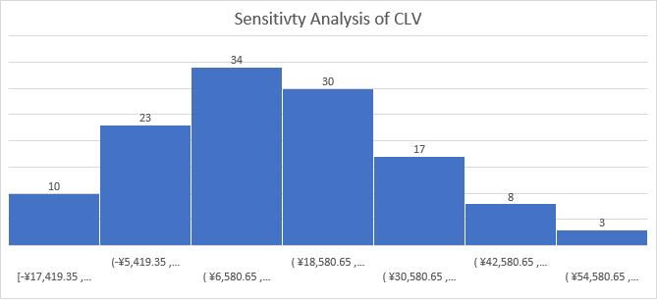

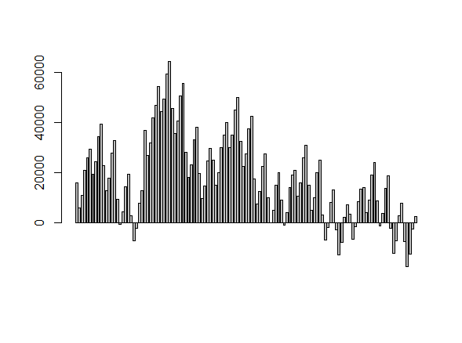

The histogram is slightly skewed to the right: meaning the average CLV is greater than the median.

There are 19 negative values for the sensitivity analysis, composing 15% of the sample. Scenarios with a high acquisition cost and low retention rate yield negative CLVs.

62 of the scenarios yield a CLV lower than the original (the original CLV is near the average). Which is about 49.6%; this is logical given the definition of average: half of the values being greater than the 50th percentile and the other half lower than (in a normal distribution).

After this analysis, I have the same level of confidence in Part 1 calculations. The measures of central tendency fall near the initial CLV calculated in Part 1: indicating a good estimate.

Changes in R are more significant than M or AC; because increasing retention rate increases CLV at an increasing rate. The other variables have linear relationships with CLV. Broadly, Maru should focus on increasing R as it increases CLV the most.

**Part 3: Reflection**

From Part 1, the most prominent limitation is the assumption that the margin, retention rate, and acquisition cost reflect reality. The sensitivity analysis reveals that 49% fall below the predicted CLV in Part 1. One should note the importance of retention rate in capturing customer value as it contributes at an increasing rate. As a manager at Maru, I would feel confident using the numbers provided to determine the marketing strategy because the values in the sensitivity analysis hover near the value determined in Part 1; this indicates a reasonable estimate.